**SL4J Logging exercises**

**Exercise 1: Logging Error Messages and Warning Levels**

**Code:**

**LoggingExecution.java**

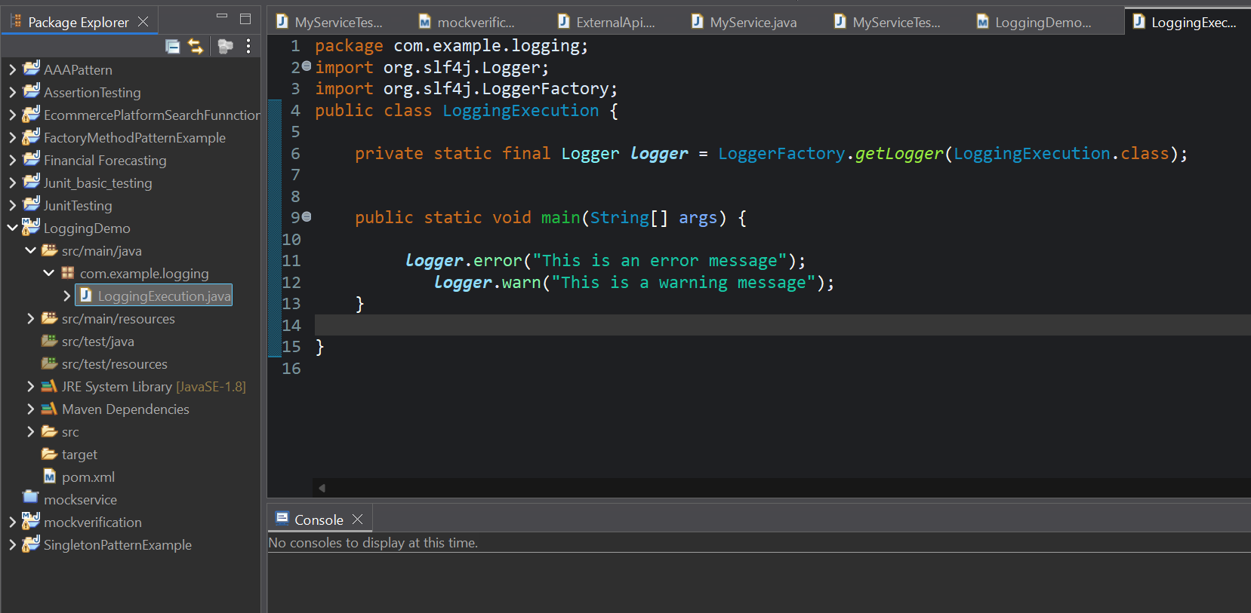

**pom.xml**

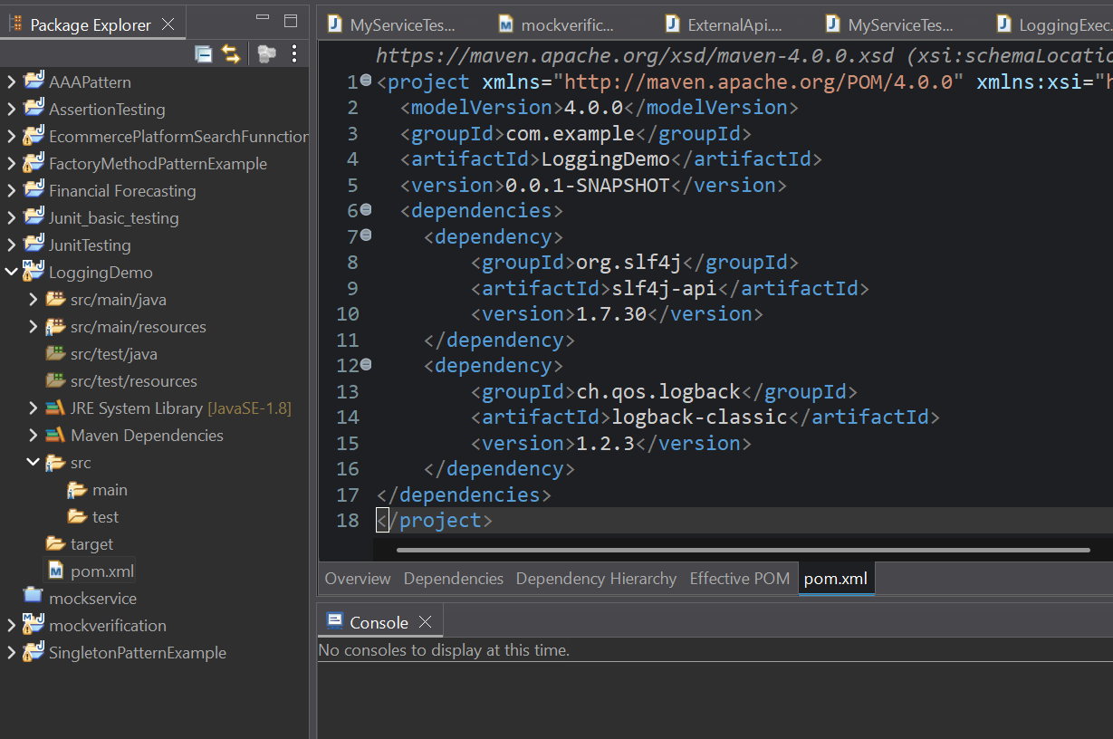

**Output:**

